

Henan Hengxin Boiler Manufacturing Co., LTD

Product testimonials

400,000 kcal horizontal fuel gas heat conduction oil furnace

**Contact personnel:**

**contact number:**

**Address: Heng, Taikang County,**

**Zhoukou City, Henan Province**

**Letter industrial park**

catalogue

**[1. List of quality matching 3](#_Toc27436)**

**[2. technical parameter: 4](#_Toc21572)**

**[3. company profile: 5](#_Toc24869)**

**[4. Company qualification and product display 6](#_Toc19257)**

**[5. Introduction and features of the equipment 16](#_Toc24393)**

**[1. summary 16](#_Toc24291)**

**[2. Product characteristics and specifications 16](#_Toc21672)**

**[3. structural property 17](#_Toc24013)**

**[4. Determination of the tube flow velocity 17](#_Toc27251)**

**[five, applied range 18](#_Toc21999)**

**[VI. Process flow 18](#_Toc549)**

**[seven, emergency control 19](#_Toc2224)**

**[eight, Main design basis 20](#_Toc3580)**

**[Vi. Customer visit 21](#_Toc17409)**

**[Vii. Equipment support 22](#_Toc24098)**

**[VIII. Safety and quality assurance measures 23](#_Toc29023)**

**[1. Safety assurance measures 23](#_Toc4151)**

**[2. Quality assurance measures 23](#_Toc29108)**

**[IX. After-sales service commitment 25](#_Toc31775)**

**[1. Service system 25](#_Toc21871)**

**[2. Pre-sale service 25](#_Toc4153)**

**[3. After-sales service 25](#_Toc14936)**

**[4. Standardized service standards 25](#_Toc24693)**

**[5, Star service 1,2,3,4 mode 25](#_Toc9436)**

**[6. Technical services and contact 26](#_Toc1757)**

**[7. Organizational guarantee 26](#_Toc6379)**

**[X. Factory environment 27](#_Toc10628)**

**[Xi. Company message 30](#_Toc5791)**

**1. List of quality matching**

**YYQW-500 YQ organic heat carrier furnace productsconfigureinventory**

|  |  |  |  |  |  |  |
| --- | --- | --- | --- | --- | --- | --- |
| **order number** | **product name** | **Product model number / specification** | **unit** | **quantity** | **place of production·brand** | **remarks** |
| **one** | **Boiler host** | | | | |  |
| 1 | Boiler host | YYQW-500YQ | short for Taizhou | 1 | Henan hengxin |  |
| 2 | chimney | Ontology supporting | M | 9 | Henan hengxin |  |
| 3 | Screw nut | M12×35 | cover | 20 | Zhengzhou, Henan | chimney |
| 4 | Flue gas energy-saving device | JNQ-40 | short for Taizhou | 1 | Henan hengxin | Customer selection |
| **two** | **Electrical system** | | | | |  |
| 1 | navar | HXDK-40 | short for Taizhou | 1 | Henan hengxin | touch screencolor screentype |
| 2 | Thermoelectric corner | WRE（0-500℃） | individual | 2 | Purchase and sale supporting facilities |  |
| 3 | electro connecting pressure gauge | Y-150（0-1.6MPa） | individual | 2 | Purchase and sale supporting facilities |  |
| 4 | bimetal thermometer | 0~400℃ | block | 2 | Purchase and sale supporting facilities |  |
| 5 | Pressure gauge bend | emblem mark | individual | 2 | Zhengzhou, Henan |  |
| **three** | **Burner system** | | | | |  |
| 1 | burner | form a complete set | short for Taizhou | 1 | Purchase and sale supporting facilities | gas engine |
| 2 | Gas valve group | form a complete set | cover | 1 | Purchase and sale supporting facilities |  |
| **four** | **Oil circuit system-heat source circulating pump** | | | | |  |
| 1 | Hot oil circulating pump | 11KW | short for Taizhou | 2 | Purchase and sale supporting facilities |  |
| 2 | filling pump | 1.5KW | short for Taizhou | 1 | Purchase and sale supporting facilities |  |
| **five** | **Body is equipped with auxiliary machines and valves** | | | | |  |
| 1 | filter | standard configuration | short for Taizhou | 1 | Zhengzhou, Henan |  |
| 2 | oil and gas separator | 219mm | short for Taizhou | 1 | Henan hengxin |  |
| 3 | High oil trough | 700mm | short for Taizhou | 1 | Henan hengxin |  |
| 4 | Low oil trough | 900mm | short for Taizhou | 1 | Henan hengxin |  |
| 5 | content gage | standard configuration | cover | 1 | Zhengzhou, Henan |  |
| 6 | Floating ball level meter | UFQ-02 | short for Taizhou | 1 | Zhengzhou, Henan |  |
| 7 | Injection plug valve | J13W-160P | individual | 2 | Zhengzhou, Henan |  |
| 8 | Stop valve (high temperature) | PN1.6 DN80 | short for Taizhou | 2 | Zhengzhou, Henan |  |
| **six** | **Random technical data of boiler products** | | | | |  |
| 1 | Product quality certificate | YYQW-500YQ | portion | 1 | Henan hengxin |  |
| 2 | Installation instructions for use | YYQW-500YQ | portion | 1 | Henan hengxin |  |
| 3 | Copy of the manufacturing license | YYQW-500YQ | portion | 1 | Henan hengxin |  |
| 4 | Product assembly diagram | YYQW-500YQ | portion | 1 | Henan hengxin |  |
| 5 | Product ontology diagram | YYQW-500YQ | portion | 1 | Henan hengxin |  |
| 6 | Product piping and instrument diagram | YYQW-500YQ | portion | 1 | Henan hengxin |  |
| 7 | Product foundation map | YYQW-500YQ | portion | 1 | Henan hengxin |  |
| 8 | Summary table of the calculation results | YYQW-500YQ | portion | 1 | Henan hengxin |  |
| 9 | Supervision and inspection certificate | YYQW-500YQ | portion | 1 | Zhoukou pot inspection |  |
| Total total price of the above set: yuan (￥:.00 yuan) | | | | | | |
| pour: | | | | | | |

## **2. technical parameter:**

|  |  |  |  |  |  |
| --- | --- | --- | --- | --- | --- |
| **Data sheet of fuel gas conduction oil furnace** | | | | | |
| model | | | YYQW-500YQ | | |
| Heat transfer oil heating quantity | | | 500KW（40 Million Kcal / h) | | |
| Boiler workpressure | | | 1.0MPa | | |
| specifiedExport oilwarm | | | 310°C | | |
| specifiedReturn oil temperature | | | 290°C | | |
| Circulating oil flow | | | 40.267m3/h | | |
| Ontology oil storage | | | 0.35m3 | | |
| receiveThermal area | | radiation | 5.232m2 | | |
| convection | 25.87m2 | | |
| heat exchanger | 9.739m2 | | |
| heat efficiency ≥ | | | 92.5%(oil) | 92.92%(gas) | |
| exhaust gas temperature | | | 126.95°C(oil) | 125.5°C(gas) | |
| Design fuel | | natural gas/tops | | | |
| fuel consumption | | natural gas | 35-62Nm3/h(Min. working condition / maximum working condition) | | |
| tops | 23.5-50kg/h(Min. working condition / maximum working condition) | | |
| Volume of the expansion tank / m³ | | | 0.93 | | |
| Oil storage tank volume / m³ | | | 3.27 | | |
| Inner ney diameter mm | | | 273 | | |
| transportSize (length, X, width, x, height), mm | | | 2800x1600x2100 | | |
| Large of Shipping weight /T | | | 3.5 | | |
| **gasburneradaptationstandard** | | | **fuel oilburneradaptationstandard** | | |
| name | | model | name | model | |
| output power | | 120-600KW/h | output power | 250-600KW/h | |
| Natural gas flow | | 12-60m3/h | Light oil flow | 21-50.6kg/h | |
| Gas pressure | | 6-10Kpa | Recommended daily fuel reserve | 1—3 T | |
| Gas supply main diameter | | DN50-80 | Main oil supply pipeline | DN25 | |
| Combustion engine valve set diameter | | DN32 | Combustion oil pump inlet diameter | DN15 | |
| power of motor | | 0.74KW | power of motor | 0.65KW | |
| Burner power supply | | 3N AC 50Hz 400V | Burner power supply | 3N AC 50Hz 400V | |
| **Specification for supporting heat oil pump** | | **Supporting electronic control specifications** | | **Specification for matching oil filling pump** | |
| model | 80-50-200A | model | HXDK-40 | model | KCB18.3 |
| rate of flow | 45m³/h | control range | 320°C | speed | 1400 r/min |
| head of delivery | 40m | Ontology structure | box-type | rated pressure | 1MPa |
| power of motor | 11KW | fixed form | Hang type | power of motor | 1.5KW |

## DJI_0386(1)3. company profile:

Henan trust boiler manufacturing co., LTD., was founded in 2006, the factory is located in Henan Zhoukou city taikang county zhang town G311 road north, away from the high-speed and yongdeng export 1 km, production and convenient transportation conditions, the geographical environment is superior, trust is a boiler with B boiler manufacturing license and D pressure vessel manufacturing license, the company has passed the quality management system, environmental management system and occupational health and safety management system certification. In recent years, we have cooperated with a number of scientific research institutions and universities. At present, there are mainly 713 technical cooperation units of SC, thermal technology cooperation units of Xian Jiaotong University, and pilot cooperation units of Henan University. Hengxin boiler with a total investment of 96 million yuan, the factory covers an area of more than 30000 square meters, the main workshop 6000 square meters, has a variety of large special production equipment, buried arc automatic welding machine, 35mm plate machine, 80mm rocker arm drilling machine, milling edge cutting machine, shear machine, horizontal lathe, edge machine, lathe, electric crane, forklift, etc., the company has a B class boiler manufacturing qualification, by professional boiler heat team, including 2 senior engineers, engineer assistant 6 people, technical personnel 25 people, workshop technicians 206 people, annual production capacity of 4000 steam tons. Main products: steam boiler; steam generator; hot blast furnace, hot water boiler, thermal oil boiler, pressure vessel, gas boiler, fuel oil boiler, electromagnetic potstove, Fuel oil and gas vacuum hot water boiler, Electric vacuum hot water boiler, Phase-change indirect hot-water boiler, Condensing vacuum-hot water boiler, heating boiler, Bath boiler, boiling water boiler, drying dry hot air boiler, Chain grate hand-fired boiler, Horizontal three-way return-trip fully automatic steam boiler, Fuel-fired boiling water boiler, Gas-fired tea stove, Electric steam boiling water boiler, Electric steam boiler, Electric steam generator, Electric hot water boiler, Steam-water utility boiler, Fuel oil steam generator, Gas-fired steam generator, Electric steam generator, Fuel hot air furnace, Gas hot air furnace, Biomass hot air blast furnace, Biomass soda water boiler, Biomass steam generator, Steam storage tank, air reservoir, Steam drum, Divided into the cylinder, Non-standard container, Wood antiseptic tank, Wood immersion tanks and other series of products, Welcome to subscribe

Adhering to the lofty spirit of serving customers and being a century-old enterprise, the company has built a product pre-sales consultation and after-sales service system, a perfect quality assurance file, quickly solve the product installation, use, maintenance and other practical problems, to provide customers with stable and reliable technical support. Quality is the life of the enterprise, Unitrust boiler adhering to the concept of quality first, let users rest assured is our solemn commitment to you. From the boiler equipment engineering design, selection, transportation, installation, inspection, commissioning and other links, we will fully consider your needs, are fully thought of your attention. We will unswervingly pay close attention to the quality, the tireless pursuit of perfection. The after-sales service of Henan Hengxin Boiler Manufacturing Co., Ltd. is implemented in accordance with the new national "three guarantees" regulations, providing a full range of engineering after-sales service. In more than 30 provinces and regions in more than 100 cities, the implementation of professional service concept, the whole standby. Product engineering quality, transformation and upgrading and other problems, we will be user-centered throughout the whole process of tracking, regular maintenance, regular maintenance, so that all problems can be easily solved.

## 4.Company qualification and product display

**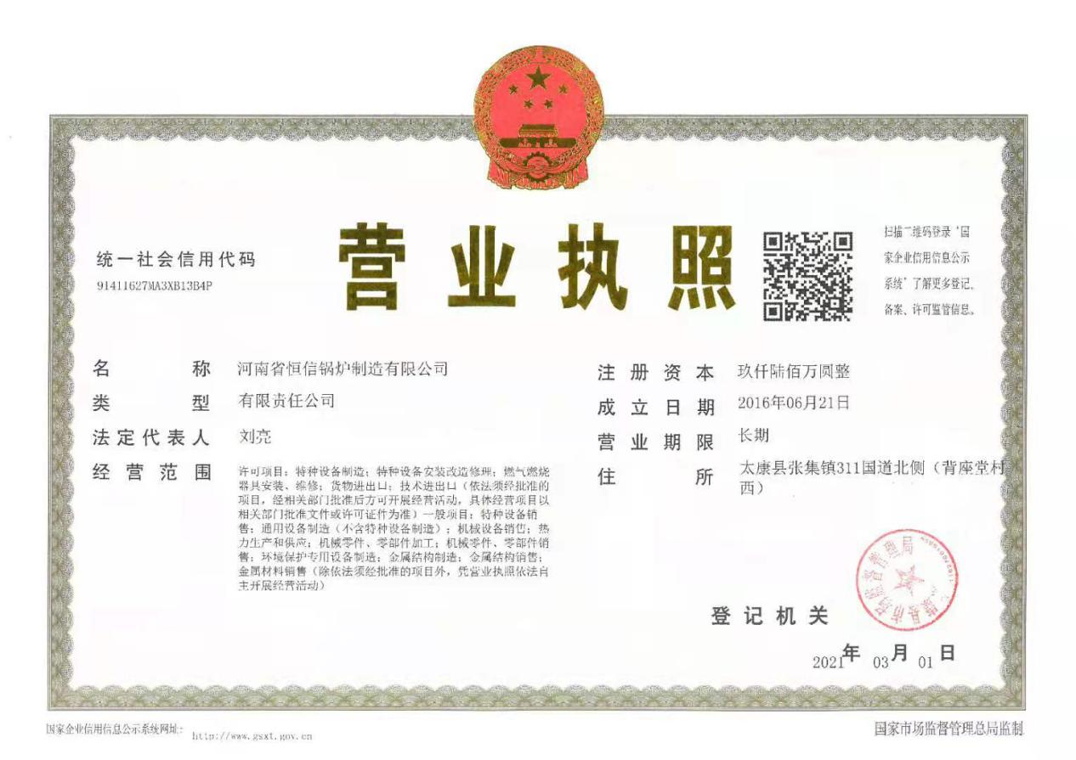**

**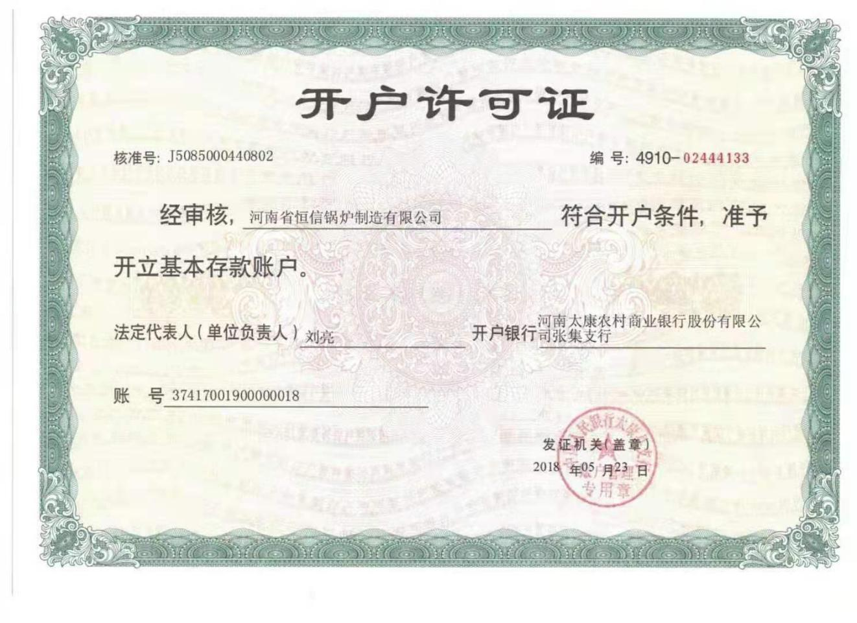**

**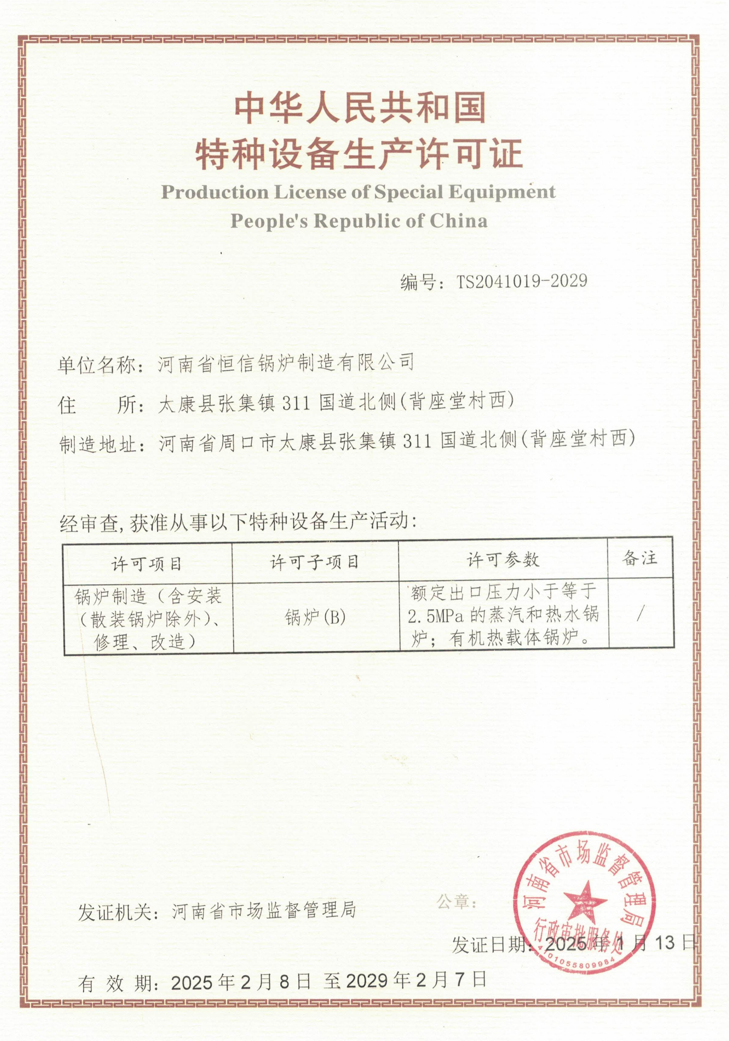**

**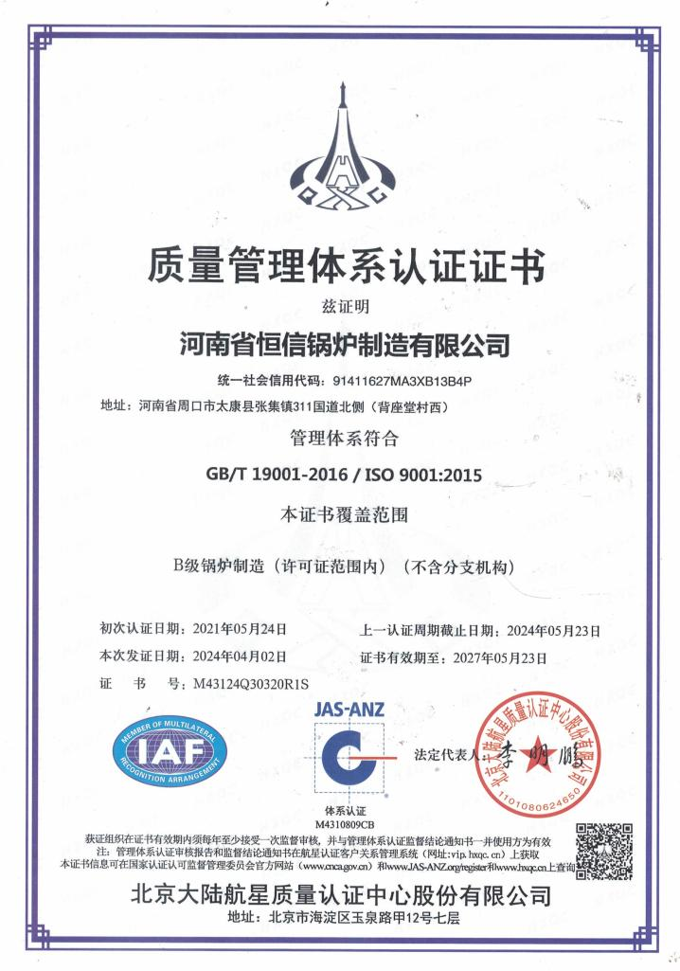**

**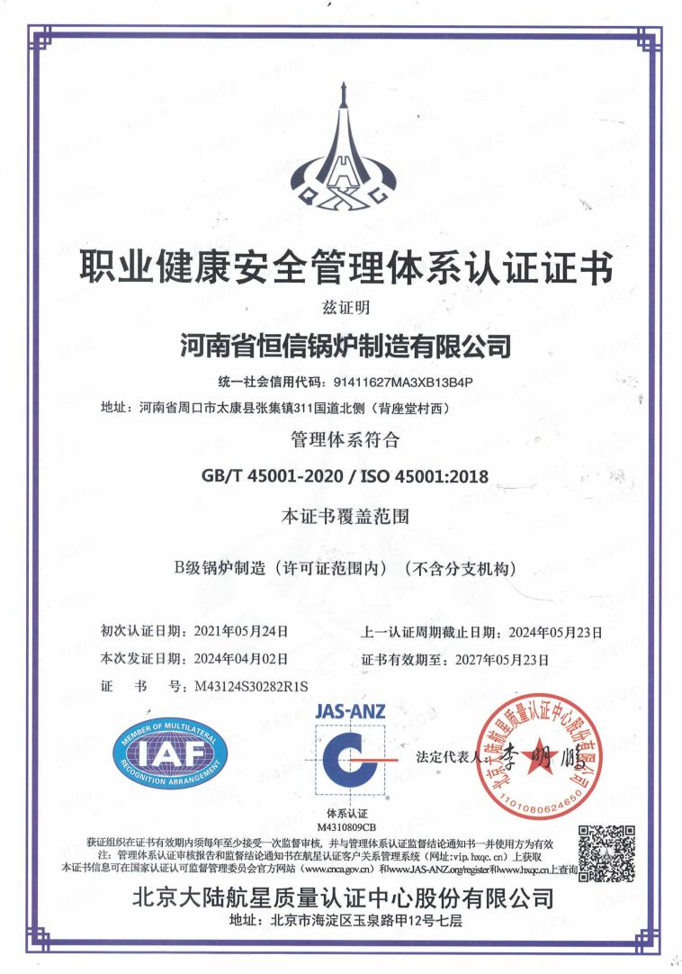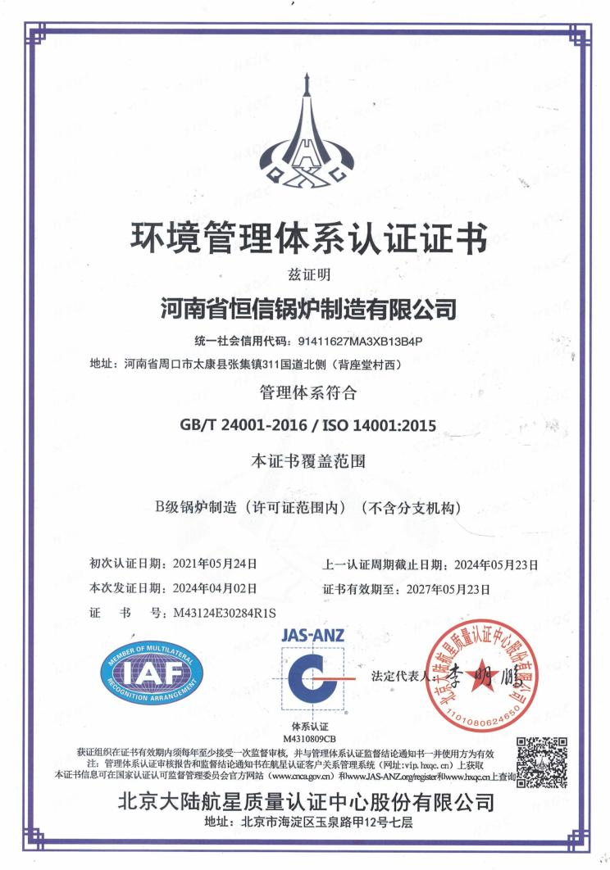**

**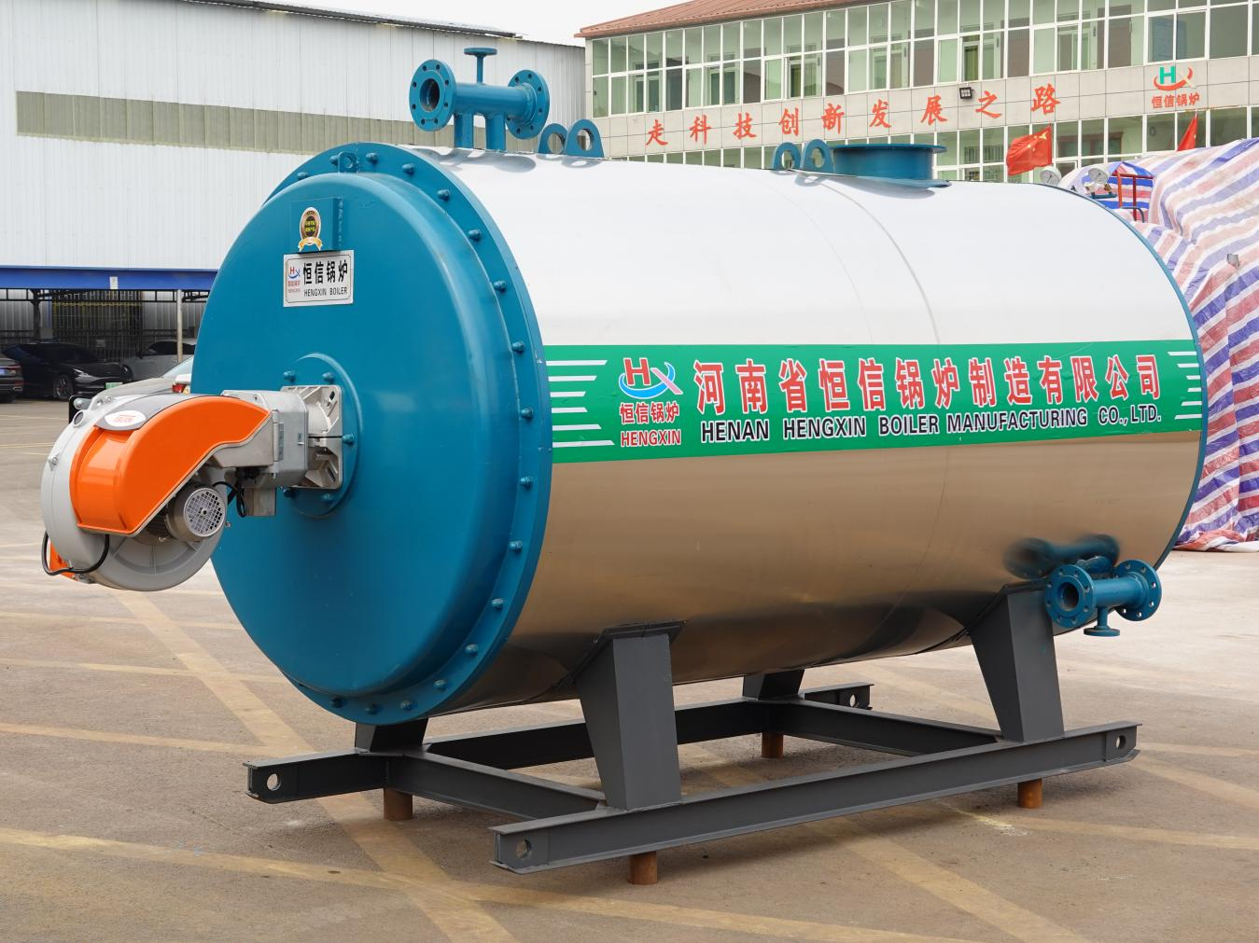**

**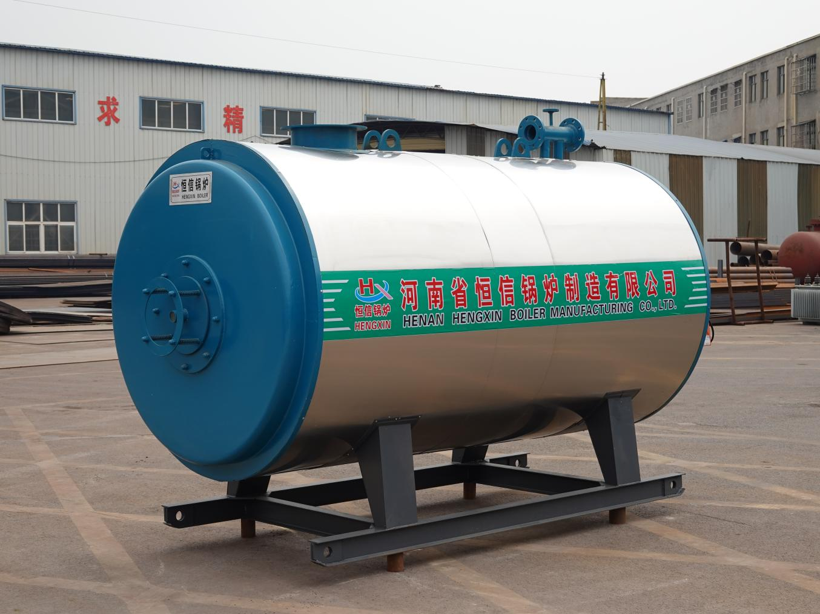**

**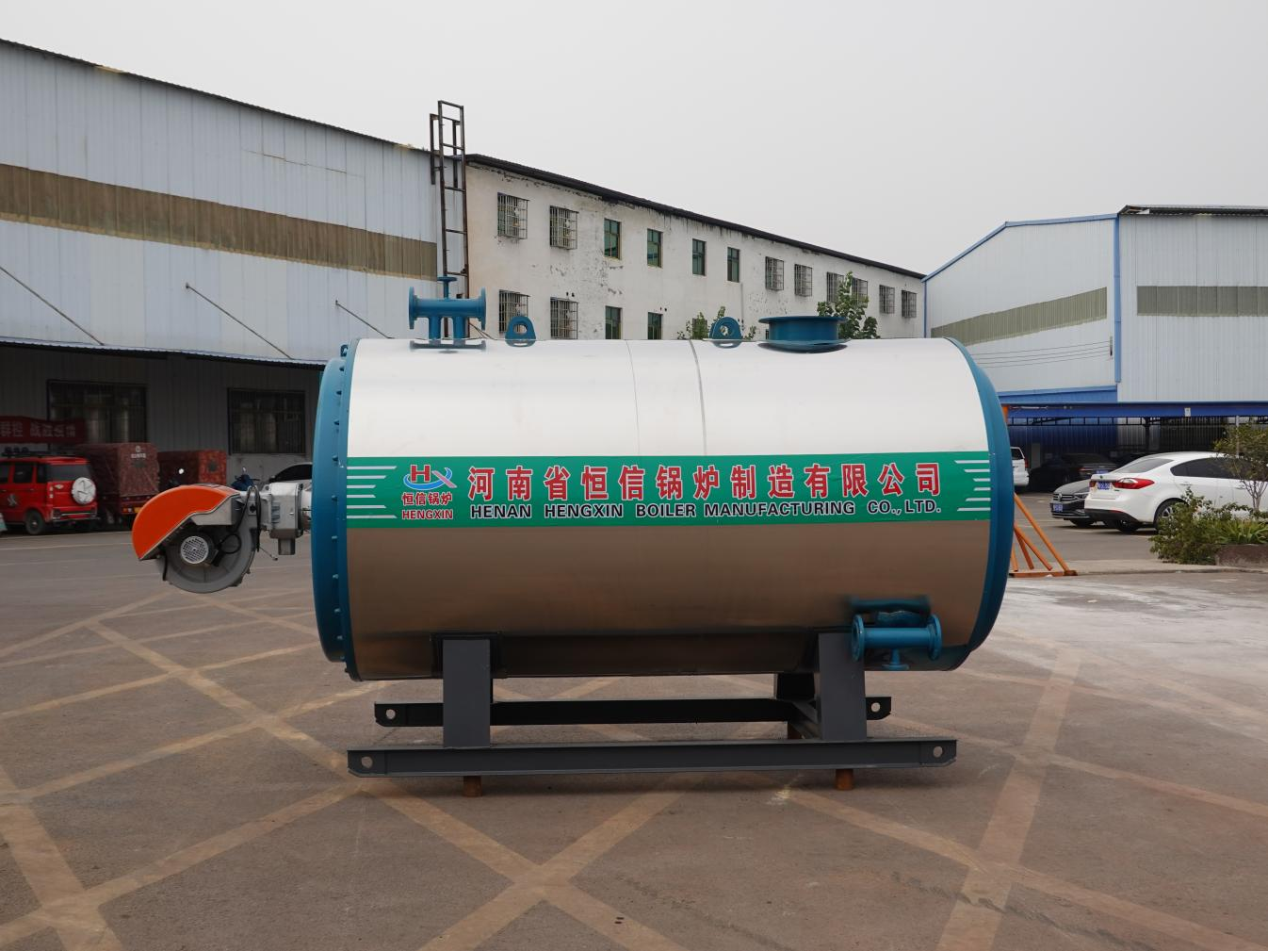**

**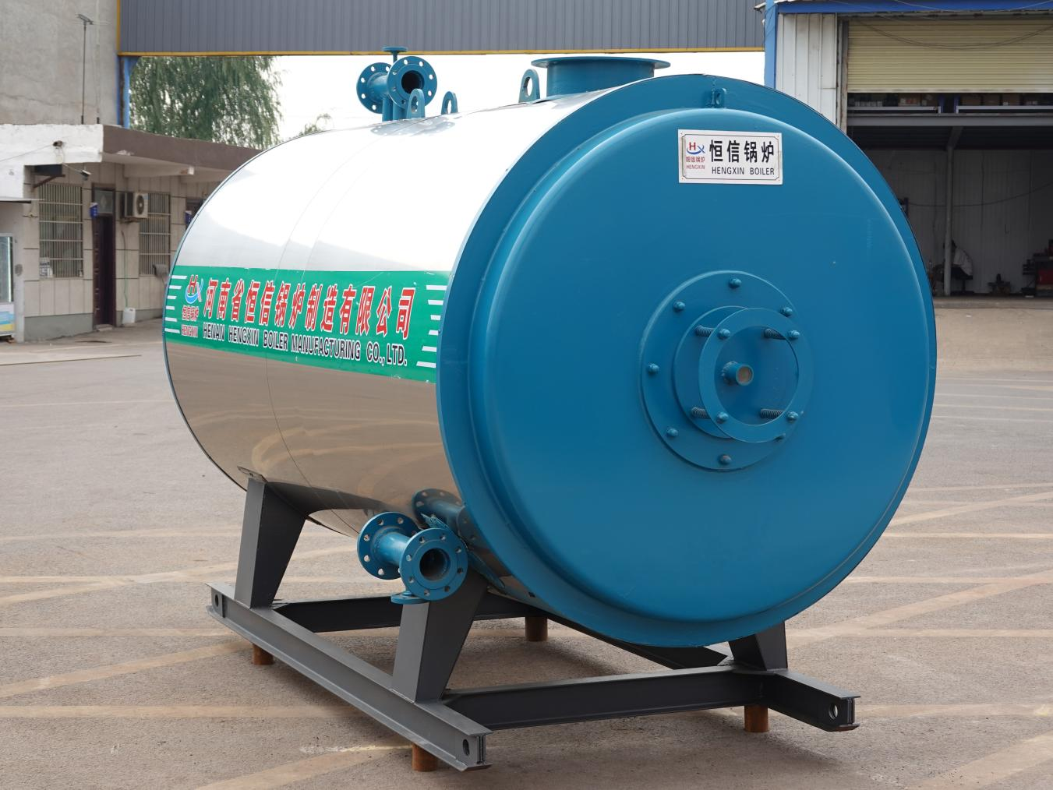**

## Introduction and features of the equipment

#### 1. summary

Organic heat carrier furnace (hereinafter referred to as heating furnace) is a kind of new type of heating equipment, with coal, oil, gas as fuel and flue gas as heat source, heat conduction oil for heat carrier through circulating oil pump forced heat carrier liquid cycle, the heat to heat equipment, then return to the heating furnace of high temperature, low pressure, energy saving equipment, heating temperature can be as high as340℃, while generally under work pressure1.0MPaBelow, because of the work in the liquid phase state, safe and reliable.

The installation and use of the boiler shall comply with itTSG G0001-2012 Boiler Safety Technical Supervision Regulations、GB / T17410-2008 "Organic Heat Carrier Furnace", GB50273-2009 "Code for Construction and Acceptance of Boiler Installation Engineering", GB13271-2014 "Boiler Air Pollutant Emission Standard", TSG G0002-2010 "Boiler Energy Saving Technical Supervision and Management Regulations" requirements. When the total injection amount of liquid phase organic heat carrier in the boiler and the system is more than 5m³, safety protection devices should be installed in accordance with the requirements of TSG G0001-2012 Boiler Safety Technical Supervision Regulations 11.3.6.2~11.4.2.

In the design of the boiler room system, on the premise of ensuring the safety performance, it should fully improve the utilization efficiency of energy, reduce the consumption of water, electricity, self-use heat and other consumption, and promote the recovery of heat energy and cascade utilization. When arranging the boiler room equipment, the length of pipe, flue duct and the number of elbows should be reduced as far as possible to reduce the flow resistance. Boiler furnace wall, smoke duct, various thermal equipment, thermal pipes and valves shall have good sealing and insulation performance. When the ambient temperature is 25℃, the external surface temperature of the furnace 300mm from the door (hole) shall not exceed 50℃, the furnace top shall not exceed 70℃, and the surface temperature of various thermal equipment, thermal pipes and valves shall not exceed 50℃. The selection of boiler medium parameters should meet the use requirements, and the rated outlet pressure and temperature of the boiler should not be too much from the pressure and temperature used.

#### 2. Product characteristics and specifications

1, Reasonable structure, advanced technology, small area, small volume, beautiful appearance, simple management, high thermal efficiency, has significant energy saving effect and economic benefits, compared with similar foreign products, the structure is unique. Furnace type is vertical and horizontal type.

2, Heating surface layout is reasonable, long service life of thermal conduction oil. The flue gas emission conforms to the national environmental protection standardsGB13271-2014. Requirements of "Boiler Air Pollution Emission Standard".

3, With accurate and reliable temperature regulation, equipped with complete operation control and safety monitoring device, high degree of automation, low labor intensity of workers; has the functions of export oil temperature overtemperature alarm and differential pressure alarm; and if the total injection amount of boiler organic heat carrier is> 5m³, it also has the functions of export oil pressure overpressure, low pressure, low flow alarm, alarm of high and low liquid level, overtemperature alarm of smoke exhaust temperature, and corresponding interlocking; (During the normal operation of the system, the furnace shall manually inspect the safety alarm devices regularly, and the boiler shall not be used in normal operation)

#### 3. structural property

1. Flow ue flow:

The boiler adopts horizontal structure, the combustion mode is chamber combustion, the fuel is light oil, natural gas. The flue gas process is: the fuel is burned in the furnace, and the high temperature flue gas absorbs heat through the inner coil. The inner ring coil outlet enters the channel between the inner ring and the outer ring to form the first return trip. From the inner coil and the outer coil outlet into the channel between the outer coil and the outer cylinder flow, forming a second return trip. Finally, the flue gas enters the rear flue through the outlet smoke box, enters the chimney after the heat exchanger, and finally enters into the atmosphere through the chimney.

2. Structural characteristics and specifications:

1) The heating surface of the furnace body adopts inner and outer coil, the pipe size is φ 573, the inner and outer rings are in parallel; the heat carrier enters the outlet container and then flows into the use system.

2) The inner and outer coil tubes are made of φ 573 pipes, and the material is 20 (GB / T3087-2008).

3) Use thermometer interface and pressure gauge interface, and φ 22X4.

4) The boiler host is made of the body, the inner body is the boiler body, and the outer body is the insulation layer.

#### 4. Determination of the tube flow velocity

Recommended flow rate in organic Heat carrier Furnace:

Radiation, V1> 2 m/s; convection, V2> 1.5 m / s

Calculation result: the inner coil is V 1 = 3.967 m/s, and the outer coil is V2=3.702m/s.

#### five, applied range

Organic heat carrier furnace has the characteristics of heating temperature and height, low working pressure and energy saving, and can be widely used in various industrial heating processes. Instead of electricity, steam and other heating, improve productivity.

（1), Petrochemical industry: polymerization, melting, condensation, distillation, strippingH2、Compulsory insulation.

（2), Oil industry: fatty acid distillation, oil decomposition, concentration, esterification, vacuum deodorization。

（3), Synthetic fiber industry: polymerization, melting, spinning, extension, drying.

（4), Textile printing and dyeing industry: hot setting, hot melting dyeing, baking, rolling light, drying, hot air pull amplitude.

（5), Plastic and rubber industry: hot pressing, hot extension, extrusion, vulcanization molding, light rolling, jet injection machine, rubber slurry mixer, conveyor belt dryer.

（6), Paper industry: drying, corrugated paper processing, light rolling machine, coating paste roller.

（7), Wood industry: multi-composite plate, density plate hot pressing forming, wood drying, steam equipment.

（8), Building materials industry: gypsum board drying, asphalt heating, asphalt concrete, emulsified asphalt, concrete component maintenance, drying equipment, linoleum production line.

（9), Machinery industry: painting and printing drying, assembly processing, cleaning and drying.

（10), Food industry: baking bread, drying biscuits, cooking pot, autoclave, conveyor belt dryer.

（11), Air-conditioning industry: industrial plant and civil building heating.

（12), Electrical equipment industry: light mill, plate press, vacuum pot, dryer.

（13), Coking industry: gas storage tank, mixing station, distribution station.

（14), Metal and casting industry: degreasing pool, phosphate treatment equipment, baking machine (room), sand core drying.

（15), Detergent industry: cooking pot, autoclave, conveyor belt dryer, fat decomposition equipment, distillation tower.

（16), Fat and paint industry: autoclave, dryer, distillation tank, cooking equipment.

（17), Automobile industry: tunnel type drying room, deatasing bath, phosphate treatment equipment.

（18), Carbon industry: graphite electrode, carbon products, asphalt melting, mixed kneading pot heating, extrusion molding.

#### VI. Process flow

Organic heat carrier furnace heating system, according to the actual situation can design different process. Composition of this process flow:

⑴Oil injection: inject thermal oil into the system, the oil source is provided by external or oil storage tank.

⑵Main circulation: heat carrier oil furnace obtains heat after heat equipment, composed of circulating oil pump, hot oil furnace, heat equipment, oil and steam separator, filter and its connecting pipes, valves.

⑶Cold oil replacement: in order to prevent the heat oil in the furnace pipe, close the system valve, open the replacement valve, and replace the hot oil in the oil furnace from the expansion tank, the oil and gas separator and the oil furnace and the connecting pipe.

⑷The excess oil of the overflow, exhaust gas and expansion tank automatically flows into the oil storage tank and expansion tank through the overflow pipe, and the gas of the oil storage tank passes from the discharge pipe to the safe area respectively.

⑸, Temperature, pressure, pressure difference display. It represents the thermal conduction oil circulation situation in the system, reflecting whether the heating system is normal or not.

⑹Auxiliary steam exhaust: in the initial dehydration stage of thermal oil, when the air volume is large, the auxiliary exhaust can be carried out through the auxiliary exhaust valve and pipeline. At this time, the vent pipe valve on the expansion tank should be closed to avoid the thermal oil from being washed away by the gas and ejected from the vent pipe. When the heating furnace is working normally, close the auxiliary valve and open the air pipe control valve. The trace gas produced in the system will be discharged through the exhaust pipe through the oil and gas separator.

⑺Bypass: open the bypass valve when stopping heating to the thermal equipment to play the bypass circulation. Close the bypass valve during normal operation, and the expansion pipe plays the role of thermal conduction oil thermal expansion overflow and automatic compensation;

**When the total injection amount of the organic heat carrier of the boiler and the system is more than 5m3, the safety protection device shall be installed in accordance with the requirements of Article 11.3.6.2~11.3.6.6 of the Boiler Safety Technical Supervision Regulations.**

1. The furnace of the flame heating furnace is equipped with an inert gas fire extinguishing system, which is generally nitrogen. The gas supply system user is responsible for themselves, and the intake pressure is 0.6MPa.

2. The boiler has the functions of outlet oil temperature overtemperature alarm and differential pressure alarm; if the total injection amount of organic heat carrier in the boiler system is greater than 5m³, it also has the outlet oil pressure, low pressure, low flow alarm, expansion tank high and low liquid level alarm, exhaust temperature overtemperature alarm and corresponding interlocking alarm; (during the normal operation of the system, the furnace shall manually check the safety alarm devices regularly, and the boiler shall not be used during the normal operation), and the closed expansion tank shall also be equipped with overpressure alarm device. Alarm and interlock with the heating device, and cut off the heating device in time.

#### seven, emergency control

**The boiler has overtemperature, low pressure, overpressure, low flow alarm control;**

1) Overtemperature alarm control: thermocouple, interface PN16, DN15;

2) Differential pressure alarm control: differential pressure alarm device, interface PN16, DN15;

3) Exit overpressure alarm control: electrical contact pressure gauge, interface PN16, DN15;

4) Low flow alarm control: flow sensor, interface PN16, DN125

#### eight, Main design basis

1. TSG G0001-2012 "Boiler Safety Technical Supervision Regulations";

2. GB / T17410-2008, Organic Heat Carrier Furnace;

3. The strength check of the compression element complies with GB / T16507.1~16507.8 Water Pipe Boiler;

4. GB50211-2004 "Code for Construction and Acceptance of Industrial Furnace Masonry Engineering";

5. GB13271-2014 "Boiler Air Pollutant Emission Standard";

6. TSG G0002-2010 "Boiler Energy Saving Technology Supervision and Management Regulations";

7. TSG G0003-2010 Rules for Energy Efficiency Testing and Evaluation of Industrial Boilers;

8. GB24747-2009, Safety Technical Conditions for Organic Heat Carrier, etc.

9. GB50273-2009 Code for Construction and Acceptance of Boiler Installation Engineering

10. GB24747-2009 Safety Technical Conditions for Organic Heat Carrier;

11. NB / T47055-2017, General Technical Conditions for Boiler Painting and Packaging, etc.

|  |  |
| --- | --- |
| **553e53655d654ac2d83ea96dfdd992e** | **d31fb64ec185d5018b272d93d058405** |
|  | **f565c635ca1a07813191056e9c0b914** |
|  |  |

**Vi. Customer visit**

## Vii. Equipment support

|  |  |
| --- | --- |
| G:\公司设备图片\膜式壁设备.jpg | |
|  |  |

## VIII. Safety and quality assurance measures

### 1. Safety assurance measures

Production must be safe, safe to promote production, adhere to the civilized and safe production is the construction quality. An important guarantee of the construction period.

(1) In addition to the full-time safety personnel, the site shall adhere to the principle of production must be in charge of safety, and arrange the safety work while arranging and checking the construction tasks.

(2) When assigning tasks to the construction team, the written safety measures must be disclosed. To briefly explain the safety points in the construction, the team leader must give oral safety tips before the shift every day.

(3) No one shall enter the site without wearing a helmet, and the safety officer and any employee can persuade them to leave the site. Site construction workers should do complete safety protective equipment, do not wear labor protection protective equipment to enter the site construction.

(4) Safety belts must be fastened for aerial work, and lifting equipment and steel parts should be connected with reliable safety cable facilities for hanging safety belts.

(5) The equipment and rigging of the lifting and transportation operation shall meet the regulations, the operation shall comply with the regulations, the construction scaffolding shall be safe and reliable, and the climbing escalator shall be set up.

(6) Temporary power power should have a temporary distribution box that meets the requirements, all equipment have good rain prevention measures, electrical equipment reliable grounding and electrical protection, not a brake multi-purpose, and maintained by special personnel.

(7) Do a good job in fire prevention work, gas welding shall not use fire rope, after work to check and extinguish all fire sources, oxygen, acetylene gas, oil and other flammable items should be extensive, construction materials according to the regulations neatly stacked, shall not occupy drainage and access channels.

(8) Adhere to the civilized construction, the construction site often keep clean, organized.

(9) Strengthen safety education, focus on homework, do not chat or AWOL.

(10) Abide by the relevant provisions of the construction unit, to violate the provisions, disorderly work, reckless, do not listen to dissuasion, to be investigated for responsibility, or even transfer from the local construction project.

### 2. Quality assurance measures

(1) Manufacturing and inspection in strict accordance with the "Special Equipment Safety Supervision Regulations", "Boiler and Pressure Vessels Manufacturing Supervision and Management Measures", "Boiler and Pressure Vessels Manufacturing License Conditions" and "Steam Regulation" and other regulations and relevant standards.

(2) There are more than 30 professional engineers and technicians of boiler, machining, welding, nondestructive testing and other related personnel. At the same time, there are 43 certified welders and 6 non-destructive testing personnel.

(3) The production equipment has more than 50 sets of plate rolling machine, driving, pipe bending machine, pipe lofting and testing platform, drilling machine, thread pipe machine, automatic welding machine, welding material drying equipment, machining equipment and so on. The main inspection and test equipment are: hydraulic test pump, air compressor; material test machine, V-gap impact test machine and projector, chemical automatic analyzer, X-ray detection machine, ultrasonic detection machine and other more than 20 sets. Fully can meet the production and inspection needs.

(4) Have a complete and sound "Boiler Quality Manual", procedure documents, operation document management system, quality job responsibilities and other quality and safety documents. The enterprise continues to strengthen quality management, strengthen production, process, welding, physical and chemical test and nondestructive testing and other aspects of quality supervision and inspection work, to ensure the quality of factory products.

(5) Do a good job in after-sales service, actively deal with and solve the quality problems of user feedback, and solve the problems for users.

(6) The design drawings shall be reviewed in strict accordance with the specifications and standards, and put into production after examination and approval by the provincial AD department.

(7) We promise to provide complete technical documents and drawings.

## IX. After-sales service commitment

### 1. Service system

Our service tenet is "to provide customers with sincere, high-quality service". We are honest and trustworthy to customers, thoughtful service and committed to constantly improve the quality of service, improve user satisfaction.

### 2. Pre-sale service

(1) Patiently introduce the product and the quality situation to the users in detail.

(2) Provide users with technical consultation, including the use and maintenance of products, product assembly, use characteristics and other technical problems, where the user needs to provide services, the company will send the best engineering and technical personnel to customer service and technical consultation.

(3) The company sets up a service hotline for users to answer various questions about products.

### 3. After-sales service

(1) When the user has quality problems using our products, he receives a customer complaint to reply within 2 hours. If the telephone communication cannot solve the problem (except that the customer does not cooperate), the service personnel can go to the site to solve the problem according to the actual situation.

(2) All expenses incurred in handling the problems (quality problem company) shall be borne by the Company (except for artificial operation by the buyer).

Implement the "product quality management system". After the contract is signed, from the product manufacturing, warehousing, delivery to installation, trial operation, the person is responsible for, improve the quality of the project.

### 4. Standardized service standards

(1) Provide detailed and enthusiastic consultation services before and during the sale

(2) Door-to-door debugging, demonstration guidance, ensure to provide perfect technical guidance, operation training

(3) Establish an independent user file card for each customer, and implement regular tracking service.

### 5, Star service 1,2,3,4 mode

1) A result: service satisfaction

2) There are two ideas: take away the troubles of users and leave the sincerity of innovation

3) That is, three controls: the service complaint rate is less than 1 / 10,000, the service omission rate is less than 1 / 10,000, and the service dissatisfaction rate is less than 1 / 10,000

4) There are four problems: one to record the problems reported by the users; one to address the problems; one to review the results; one to report the results to the design, production and operation departments.

### 6. Technical services and contact

1) The company assigns Mr.Zhao Chunhui, as the person in charge of technical service.

2) The technical support provided includes: technical explanation work in the bidding documents, liaison work in the production process, on-site guidance on product installation and debugging, and solving difficult questions about products.

### 7. Organizational guarantee

Our company has specially set up a special project department for each user, and a special person is responsible for, tracking, dealing with and coordinating some problems in the manufacturing process of the project, and the responsible personnel must report the problems at any time.

## X. Factory environment

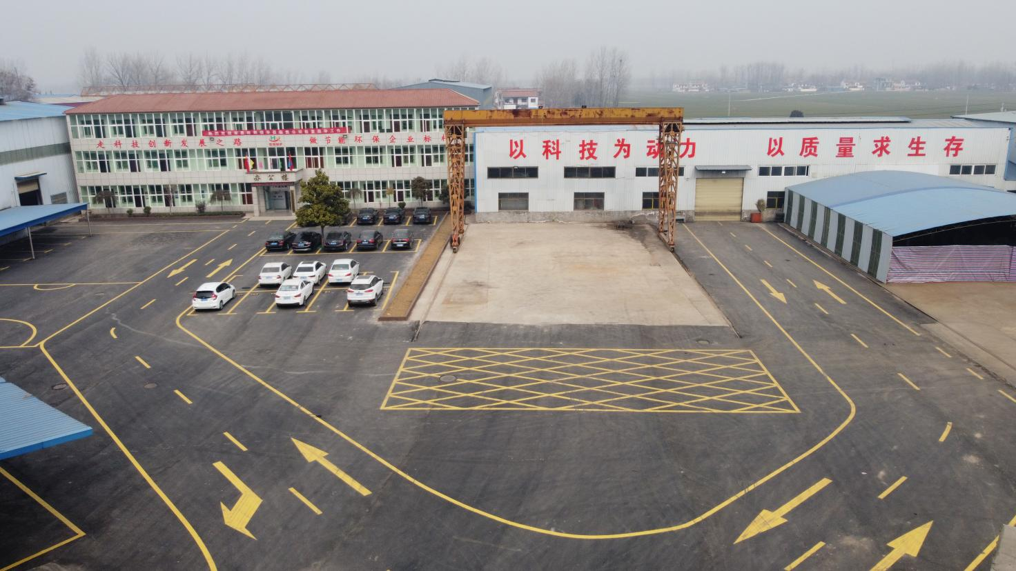

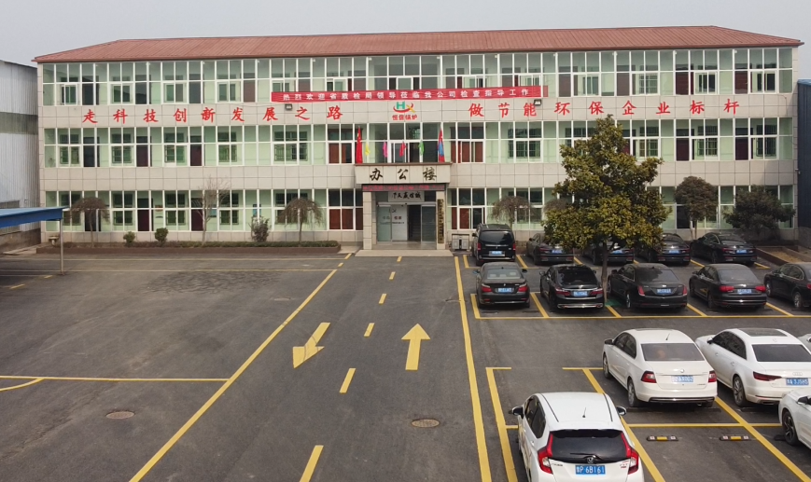

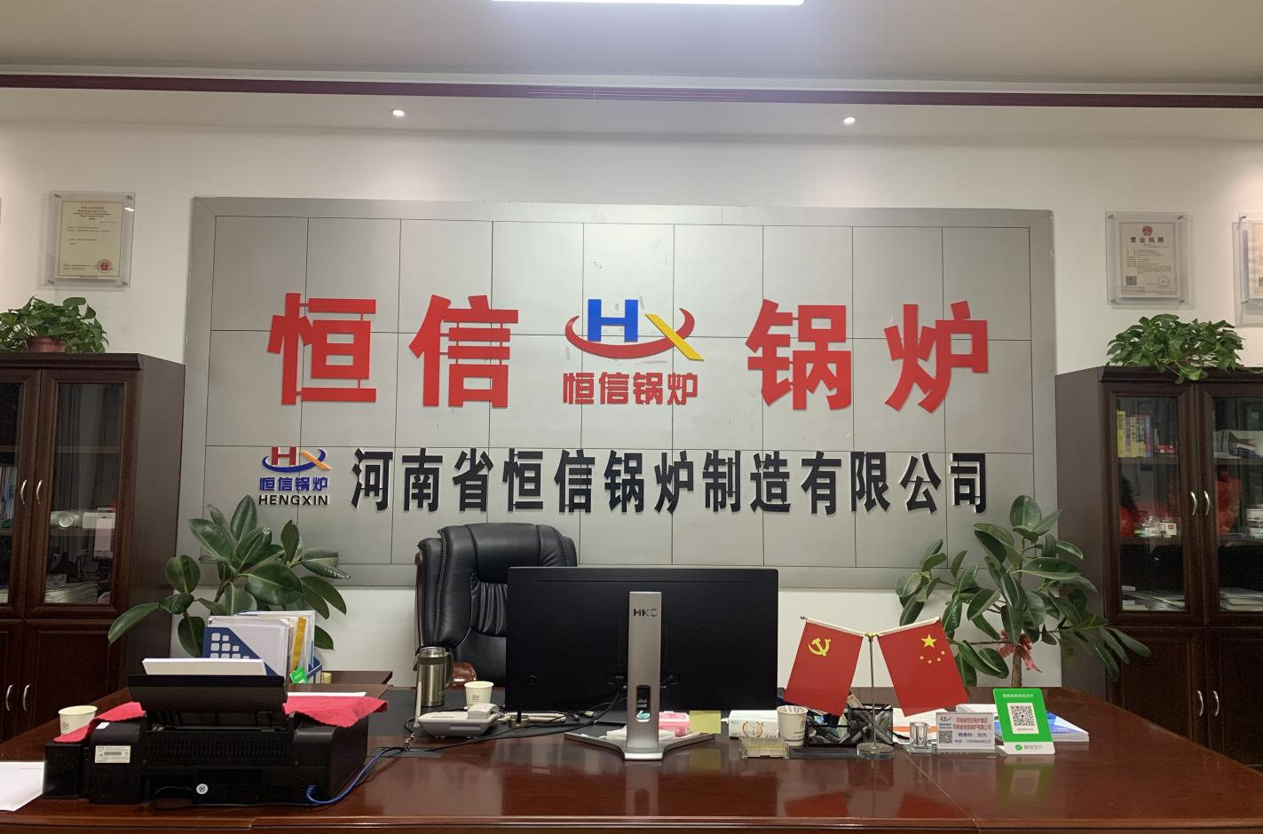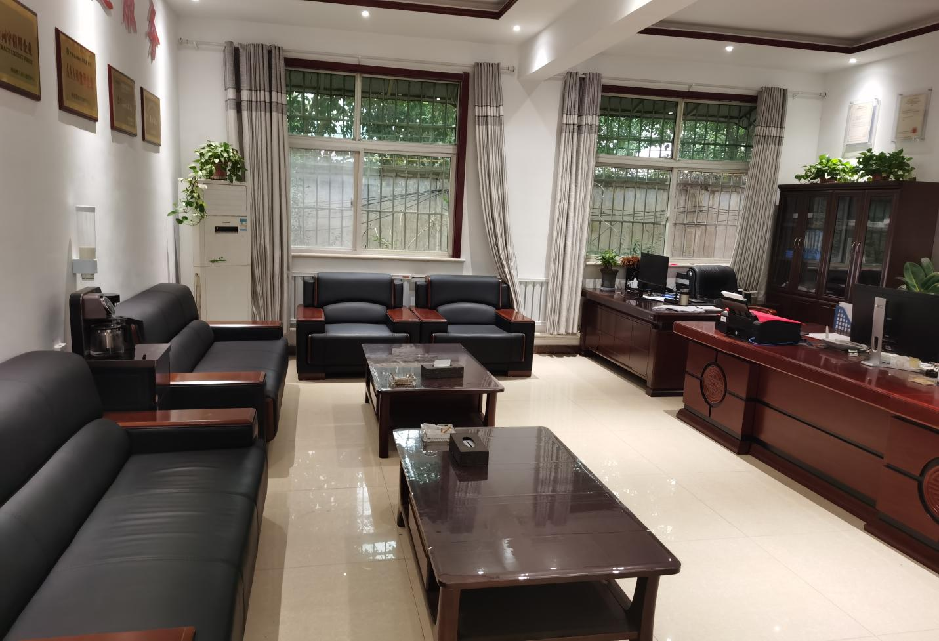

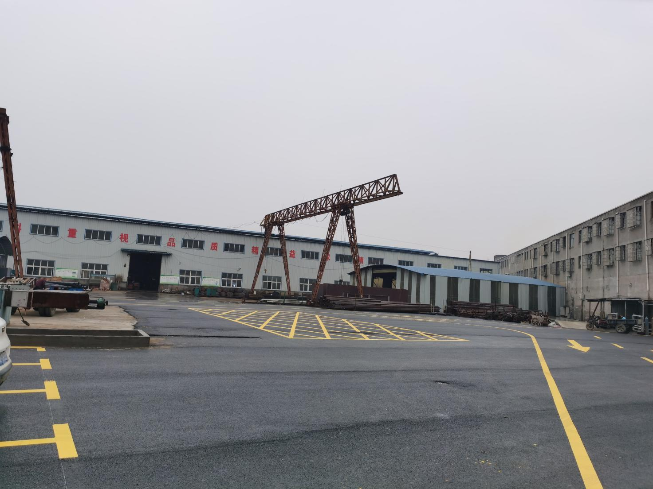

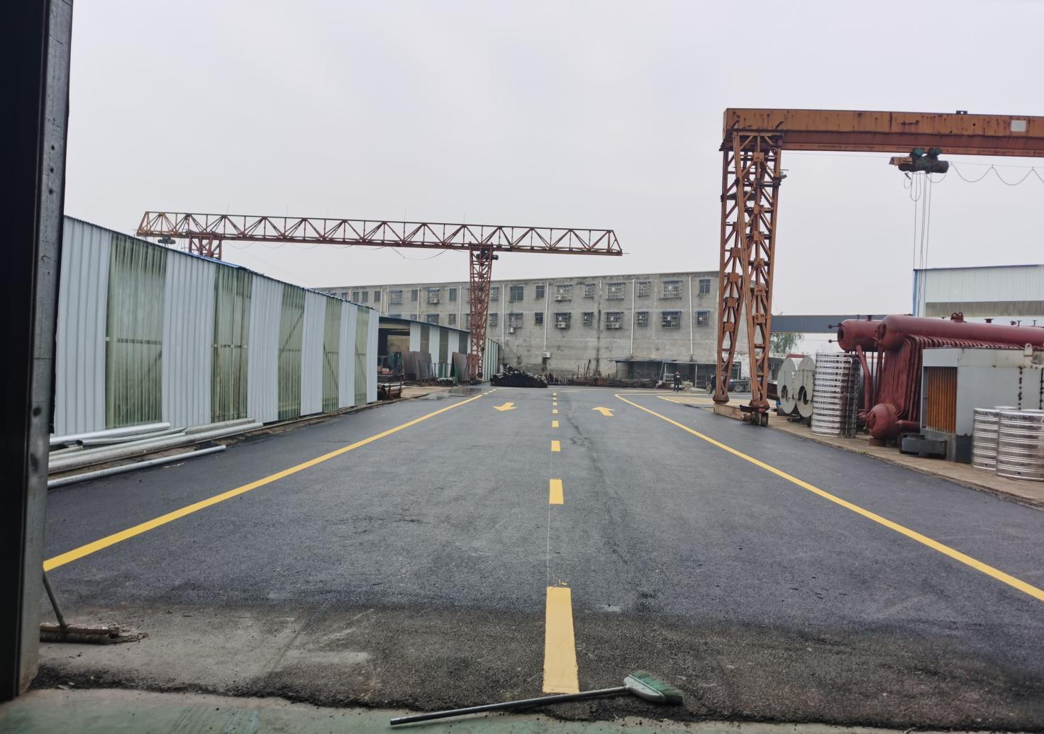

**Eleven, the companysend word**



This listFor your company reference

Due to the supply factors, the equipment parameters shall be subject to the actual factory equipment parameters!

We speak adhering to the principle of customer first, in ensuring technology, quality at the same time, to provide customers with pre-sale and after-sales services, to solve customers worries, will be patient, sincere enthusiasm attitude to serve every customer!